Leadership Presence: The Ariel Model

Leadership Presence
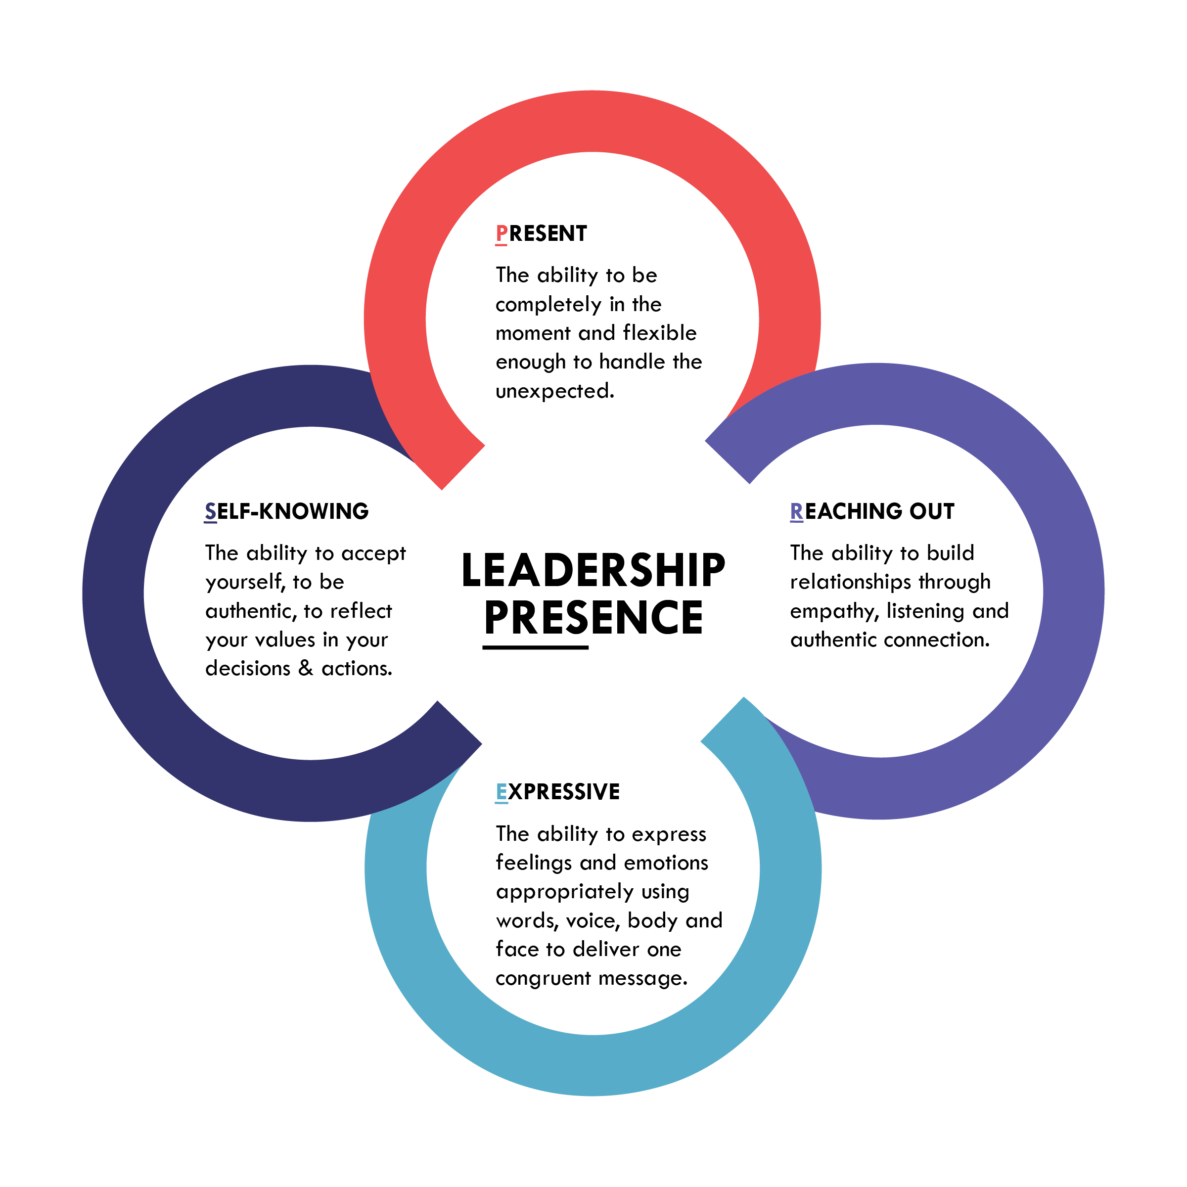
The ability to authentically connect with the hearts and minds of others in order to motivate and inspire them towards a desired outcome.

